# Staff Report

Meeting Date: May 7, 2024

To: Siskiyou County Board of Supervisors

From: Hailey Lang, Planning Director

Subject: Appeal of the Siskiyou County Planning Commission regarding the Golden Eagle Use Permit (UP-23-08) project and associated CEQA Addendum

## Background

Golden Eagle Charter School submitted an Application for Development Review for a Use Permit (UP-23-08) at location 1030 W A Barr Road in Mount Shasta (APN: 036-230-361). The application was deemed complete on September 11, 2023. The Use Permit request was to increase the school capacity from 60 students to 225 students and 35 staff as well as construct a 28, 300 square foot school building and a 960 square foot modular classroom. The existing school is approximately 8,150 square feet and there is an existing 1,920 square foot modular classroom. The existing use permit (UP-96-03) for the project site includes allowance of an existing K-8 school in conjunction with church facilities and operations. The proposed Use Permit will rescind the previous use permit (UP-96-03) and will remove the church operations from the use permit. Additionally, the proposed project would abandon the existing onsite septic system and connect to the Lake Siskiyou Mutual Water Company.

The Land Use Element of the Siskiyou County General Plan identifies the project site as being within the mapped resource overlay areas for Building Foundation Limitations and Woodland Productivity. In addition, planning staff has identified that Composite Overall Policies 41.3(e), 41.3(f), 41.5, 41.6, 41.7, 41,8, 41.9, and 41.18 apply to the proposed project.

Staff conducted a detailed analysis of each of the required findings and has found that the proposed project is consistent with the applicable General Plan policies governing the subject site. In addition, the use as conditioned would be compatible with the surrounding land uses, has adequate roadway access for transportation and public health and safety provisions, and would not create environmental impacts to on- or off-site resources.

The proposed project site is zoned both Neighborhood Commercial (C-U) and Single-Family Residential (Res-1). [1]

Both zoning districts allow for the operation of a school subject to a Conditional Use Permit (CUP), pursuant to Section 10-6.3703 and Section 10-6.4203 of the Siskiyou County Code. Based on staff’s analysis of the proposed use, staff believes that the necessary findings can be made for approval of the application.

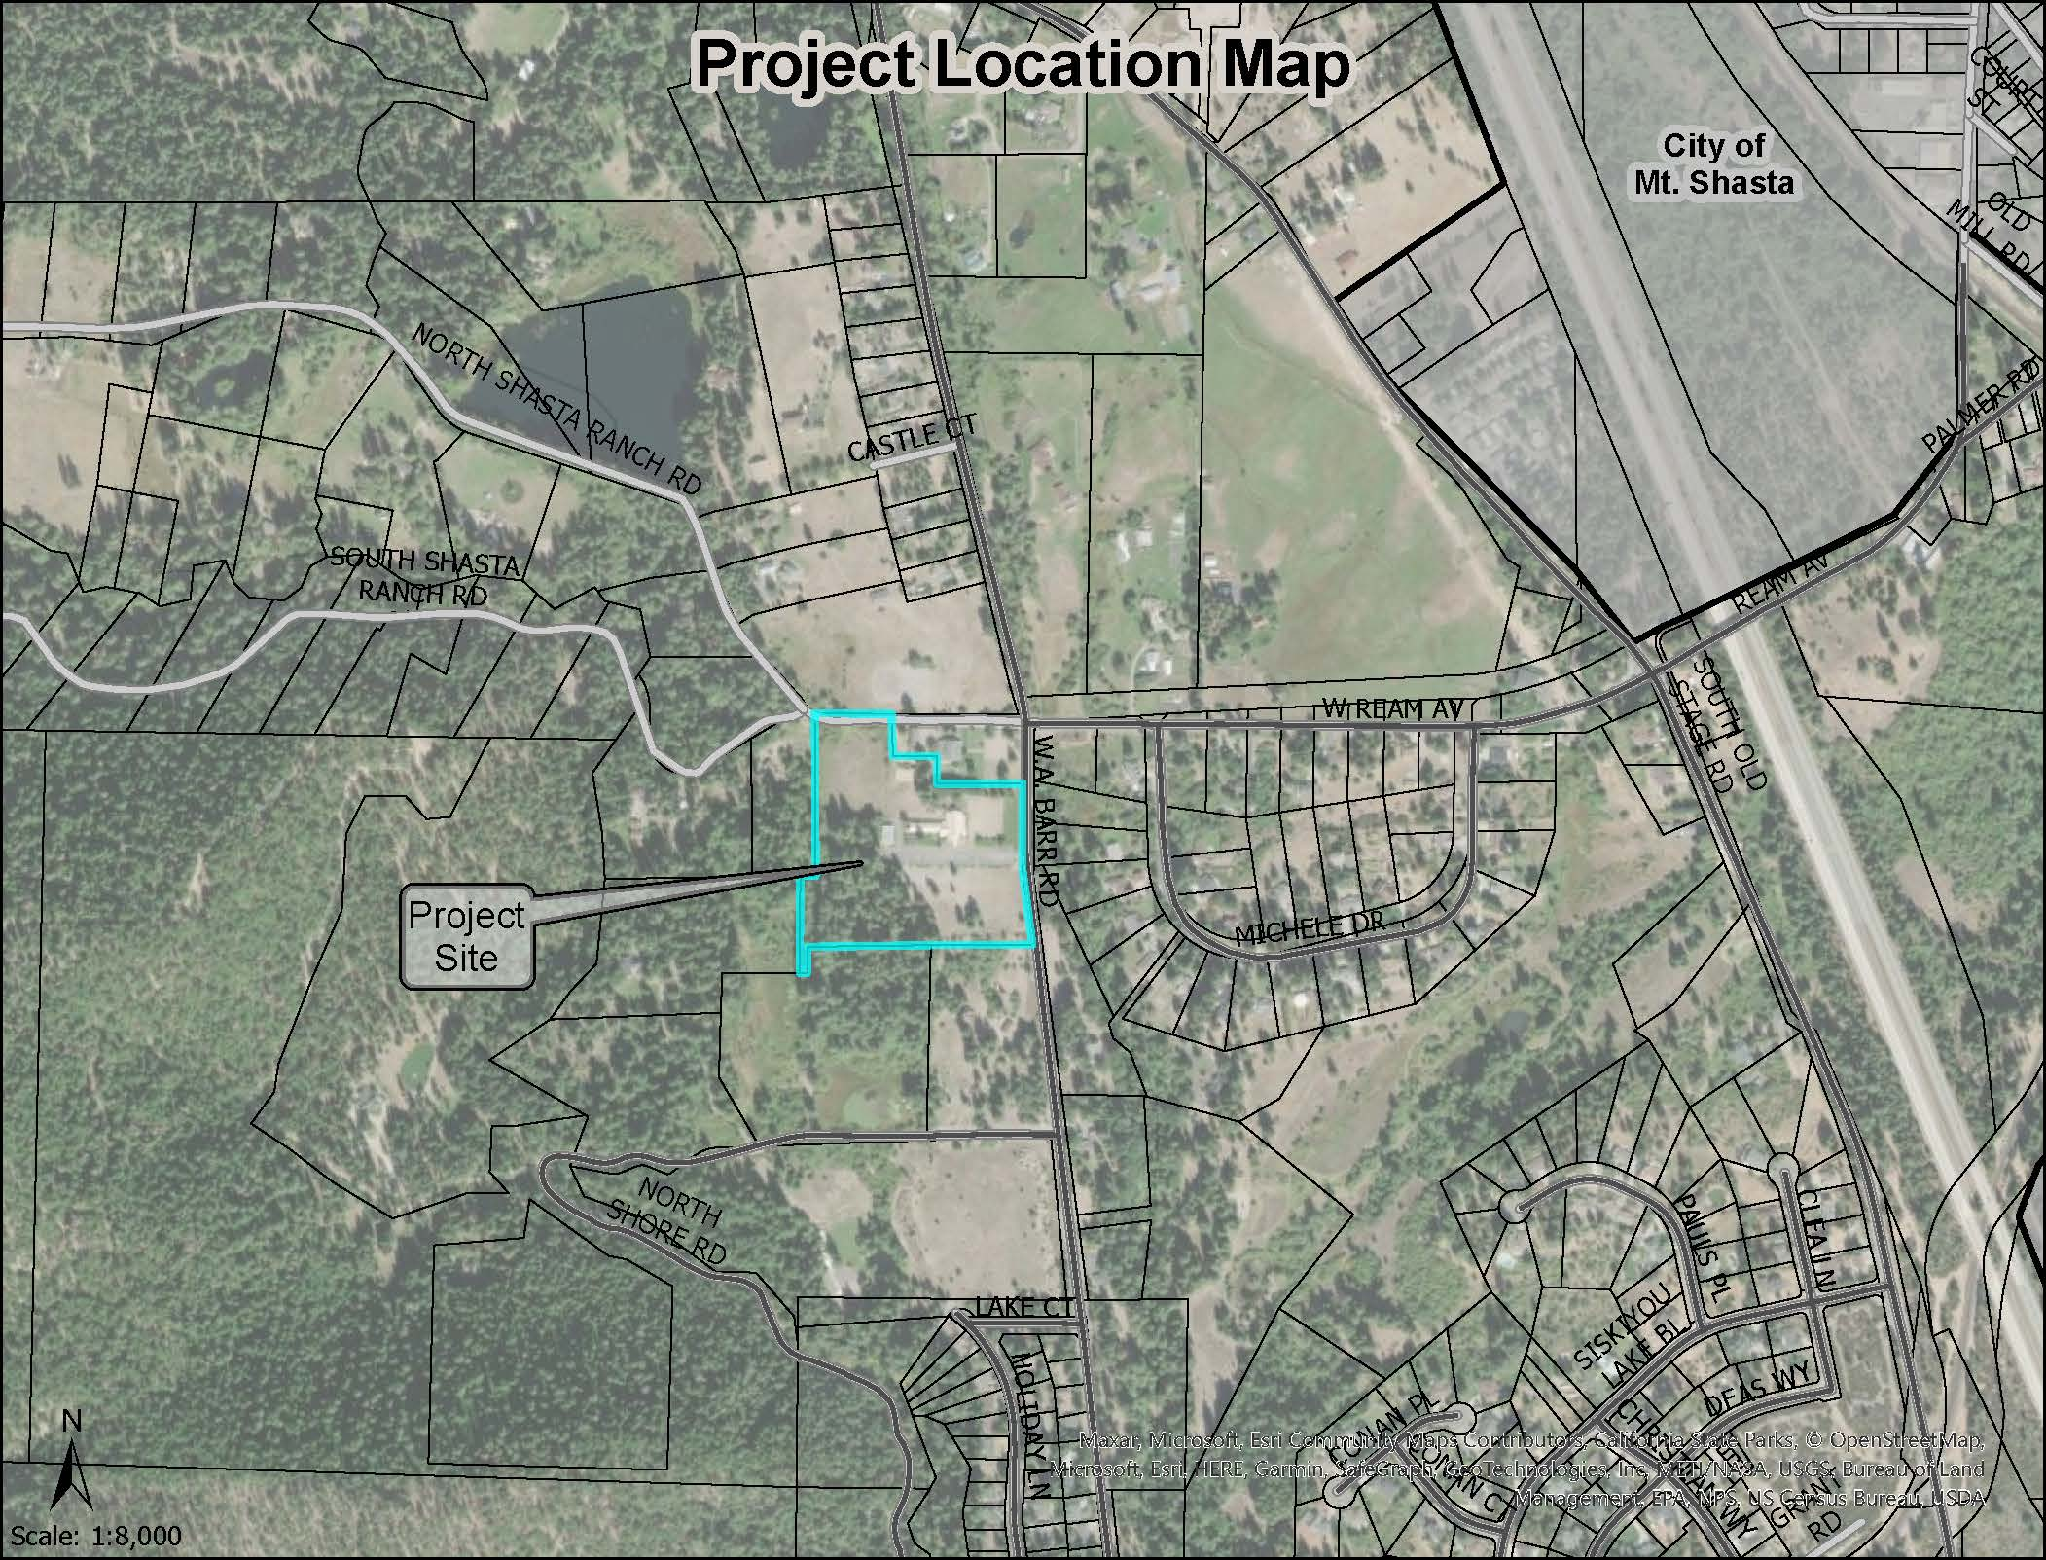  
**Figure 1: Project Location**

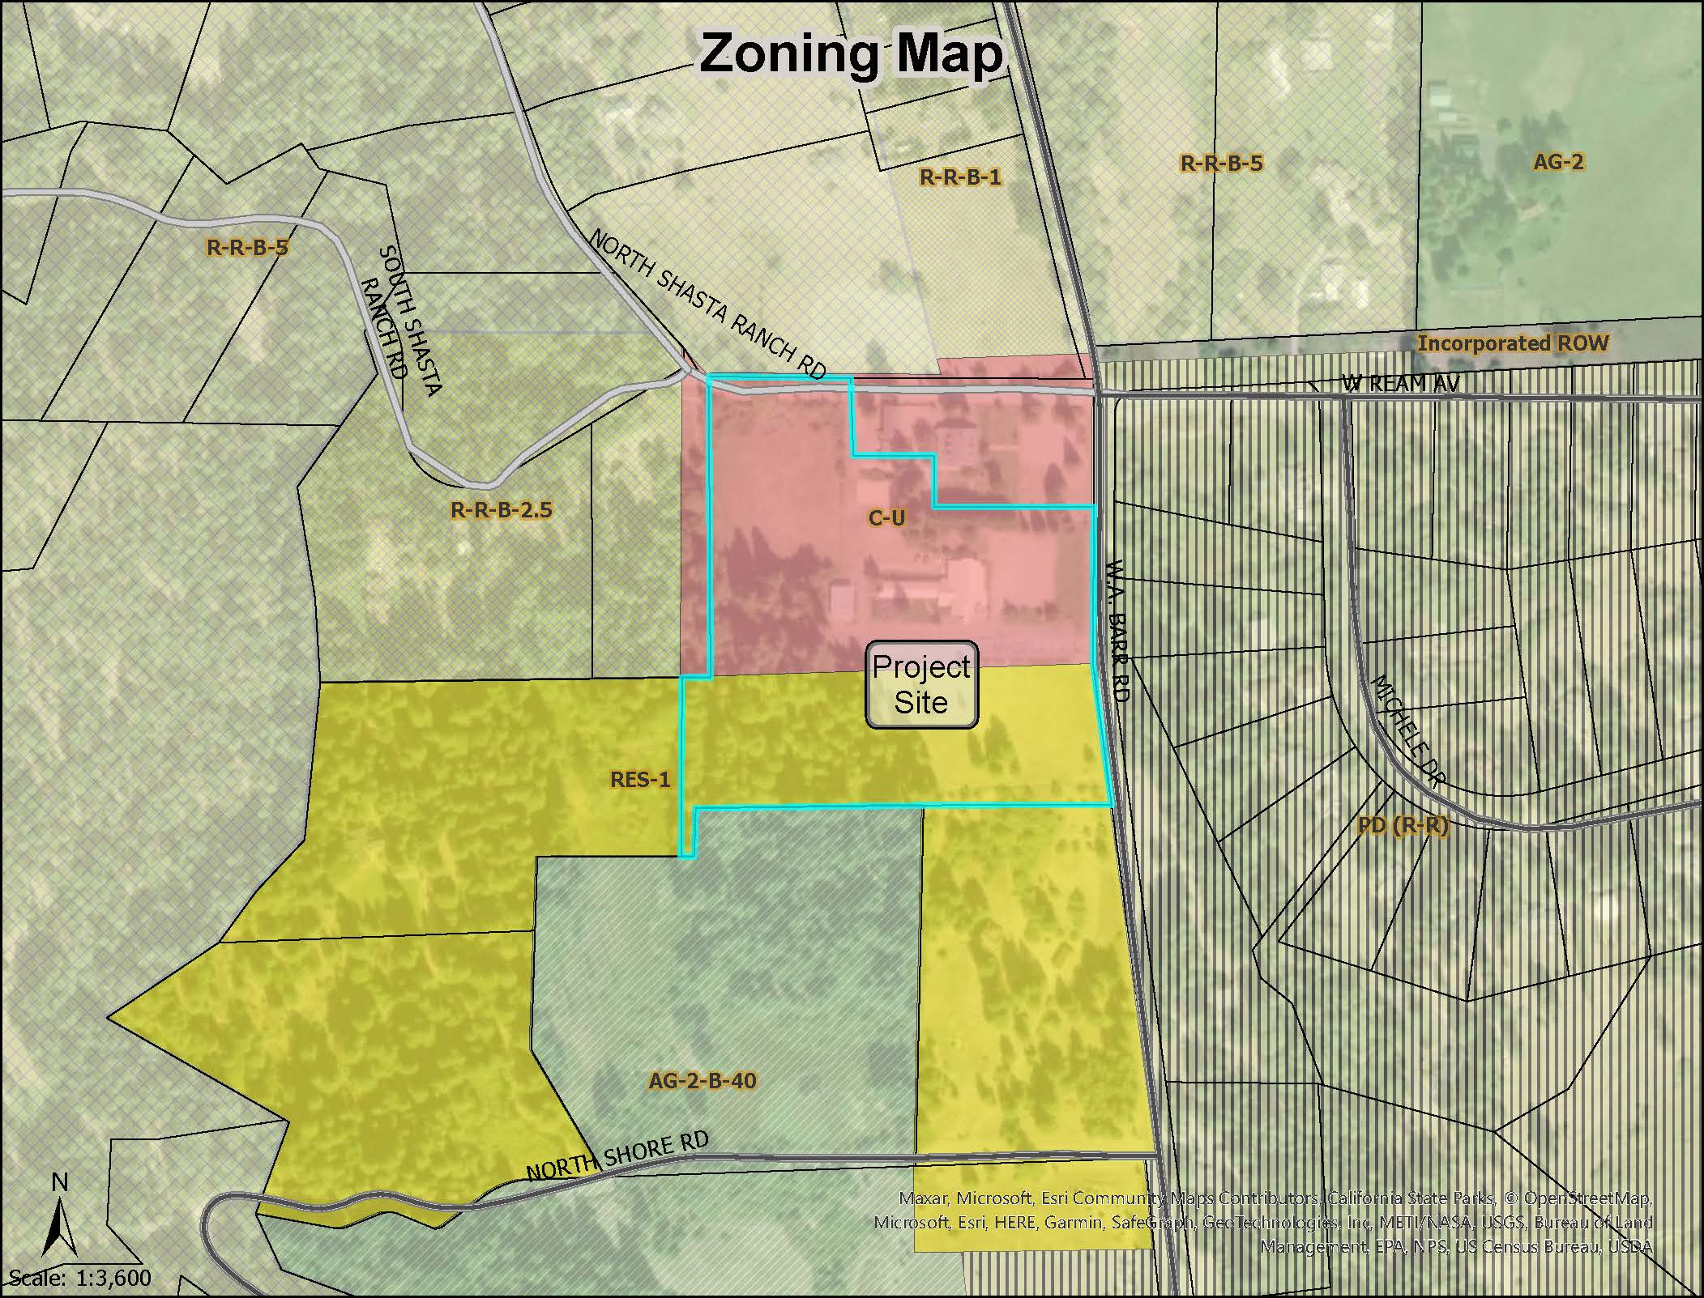  
**Figure 2: Zoning Map**

The property was developed with a church sanctuary (250-seat maximum occupancy), 79 paved parking stalls and 41 gravel overflow parking stalls, congregation hall, and related Sunday School classrooms with a play field/ball diamond. Surrounding development included the historic Shasta Ranch Bed and Breakfast Inn to the north, mostly vacant forested wetlands and a single-family residence to the west, vacant residentially zoned property to the south, and W A Barr Road and Cold Creek to the east.

The prior owner, the Evangelical Free Church of Mt. Shasta, sought approval to allow a private K – 8 school facility to be operated in conjunction with their existing church facilities. No new building construction was proposed on the 6-acre site. The school planned to accommodate 60 students. The school use was approved, and use permit UP-96-03 was issued.

Golden Eagle Charter School now owns the property and seeks to expand the school operations. The proposed project includes the addition of a modular classroom, a new school building, to change the maximum student count to 225 students and 35 staff, and to rescind the existing use permit (UP-96-03). The proposed project also seeks to abandon the existing on-site septic system and connect to the adjacent Lake Siskiyou Mutual Water Company sewer system. A revised biological survey, noise assessment, and transportation assessment were also submitted as part of this project. Below is the approved occupancy for UP-96-03 and the proposed occupancy with UP-23-08:

| **Approved Occupancy (UP-96-03)** | **Number of People** | **Proposed Occupancy (UP-23-08)** |
| --- | --- | --- |
| Church | 250 | N/A: Church operations will be eliminated |
| School | 60 | 260 |
| **Total** | 310 | 260 |

**Table 1: Permit Occupancy**

The proposed occupancy of UP-23-08 is lower than the approved occupancy of UP-96-03 since the proposed project will be eliminating church operations from the project site.

## Summary of Appellant’s Concerns

An appeal was filed on March 4, 2024, as to the Planning Commission’s approval of the project. The appeal identified several areas of concern:

1. The present school is operating unlawfully because it is not being operated in conjunction with a church, as the existing CUP requires.
2. The County did not publish notice of the Planning Commission proceeding properly.
3. The Planning Commission violated the Brown Act by not allowing full public comment at the second (February) hearing.
4. The project violated CEQA because environmental effects were considered in an addendum to the previously existing MND and other provisions of CEQA were procedurally violated (e.g. the public should have been presented, and been allowed to comment on, a MND;
5. Transportation concerns were not fully addressed, including sidewalks and bike lanes, and that the City of Mt. Shasta has a mobility plan that was not considered.
6. The application indicated “325” students were being requested, yet the student count was sometimes identified as “225” in planning documents.
7. Certain conditions of the project, such as ingress/egress routes, signage and warning lights for the road, a timeframe for construction and fencing were major changes requiring an MND and not an addendum.
8. Staff’s report for the February hearing had significant changes, but the public had only three days to review such changes.
9. The county provided no analysis to support a traffic speed reduction to 25 mph with undefined signage locations.
10. The issue of noise was not property considered and the County’s Noise Element of the General Plan is out of date and no longer valid. And, otherwise, the project is inconsistent with noise level standards.

## General Principles on Appeal – The Role of the Board of Supervisors

The Siskiyou County Code provides for “use permits”, which authorize certain kinds of uses of private property and are not otherwise automatically authorized under the Zoning Ordinance. Any proposed use permit (a “project”) goes before the Planning Commission for evaluation as to the project’s compatibility with the “public health, safety, peace, morals, comfort, convenience and general welfare” and other specific considerations as listed in SCC Section 10-6.102. Additionally, the Planning Commission considers the environmental effects of a project under the California Environmental Quality Act (CEQA).

After the Planning Commission makes a decision on the project, the decision may be appealed to the Board of Supervisors. On an appeal to the Board of Supervisors, the County Code instructs that the appeal is heard “de novo”, which means that the Board of Supervisors is not bound by the Planning Commission’s decision and is not strictly limited to whatever was presented at the Planning Commission level. (SCC § 10-6.1405.)

Ultimately, the Board of Supervisors may:

1. Uphold the Planning Commission’s decision.
2. ‘Reverse’ or modify the Planning Commission’s decision.
3. Refer the matter back to the Planning Commission with guidance as to considering any issue or new information that raises a concern.

And as to reaching a decision, the County Code requires that the “action of the Board shall be by the affirmative vote of not less than a majority of its total membership.” (SCC 10-6.1405).

## Analysis

Staff has prepared a response to provide additional information and clarification for the Board regarding the appellant claims:

1. **The Golden Eagle Charter School has been operating unlawfully in the former church building without a Conditional Use Permit for about a year, when the church's previous Conditional Use Permit for school use expired when the church was sold in January 2023.**

A use permit becomes null and void if not used within two (2) years following the date of approval (following a hearing before the Planning Commission to declare it unused). The permit in this case is not null and void because it was used within two years of approval. Second, a use permit may be revoked if any of the conditions of the permit are violated. Revocation is a discretionary act to be taken only after an opportunity to comply has been provided to the permit holder and following a hearing before the Planning Commission to revoke the permit if the condition was not corrected. In this instance, the permit holder has been actively working with County staff to resolve the situation by applying for a new use permit that does not require church operations on the premises. Initiating revocation proceedings while the matter is still pending would be counterproductive and contrary to the intent of Siskiyou County Code Section 10-6.1402.

1. **The County failed to provide the public with adequate notice of the Project's public hearing. The only published notice was in the Siskiyou Daily News, but that is not a newspaper of general circulation in the Mt. Shasta community. At a minimum, the County is required to provide advance public notice, an opportunity to be heard, and a fair hearing because these are constitutional due process rights as explained in Horn v. County of Ventura (1979) 24 Cal.3d 605.[2]**

Government Code Section 6000 defines a “newspaper of general circulation” as a newspaper published for the dissemination of local or telegraphic news and intelligence of a general character, which has a bona fide subscription list of paying subscribers, and has been established, printed and published at regular intervals in the State, county, or city where publication, notice by publication, or official advertising is to be given or made for at least one year preceding the date of the publication, notice or advertisement.

The Mount Shasta Herald newspaper is a newspaper based in the City of Mount Shasta. The notices provided in this newspaper are specific to the Mount Shasta area. The Siskiyou Daily News newspaper is a newspaper that covers all of Siskiyou County. Likewise, the notices provided in the newspaper are not specific to an area or a specific city, but on a countywide scale. When there are multiple newspapers that qualify as a newspaper of general circulation, Siskiyou County has the discretion to choose the most appropriate newspaper. The Planning Commission is a countywide commission because the jurisdiction is of the County.

It is in the best interest of the County to provide notice in a newspaper that will cover not only the city of the project but also on a countywide level so members of the County are able to provide comment on the project; not just the residents that reside in the specific city the project will occur in.

1. **The Planning Commission's approval violated CEQA because an Addendum to the Mitigated Negative Declaration is not allowed when a Project has foreseeable significant environmental impacts such as traffic safety impacts, noise impacts, and other significant impacts as identified in the public comments that were submitted.**

Generally, under CEQA, a project that is not otherwise defined as being exempt from CEQA, will begin with an examination of whether the project may create any “significant” environmental effects. If significant effects are identified but can be mitigated, a Mitigated Negative Declaration “MND” report will be prepared. An Environmental Impact Report “EIR” will be used if potentially significant effects that may still exist even after reasonable mitigation measures are imposed. Later, if a project that already has an approved MND or EIR, will be modified, that proposed modification may trigger a need for an amended MND or EIR. However, if the modification to the project will result in less than significant effects, than it is appropriate to simply use an addendum to the existing EIR.[3]  (The process and technical requirements for using an addendum are more thoroughly explained in the Environmental Review section at the end of the report.)

It was not determined from staff analysis, nor from the Planning Commission’s approval of the Addendum, that the present project has foreseeable *significant* impacts. CEQA Guidelines define a “significant effect on the environment” as a “substantial, or potentially substantial, adverse change in any of the physical conditions within the area affected by the project including land, air, water, minerals, flora, fauna, ambient noise, and objects of historic and aesthetic significance.” (14 Cal. Code Reg. § 14382).

As part of the hearing process, public comments as to whether an effect is significant must be credible and factually based. Pursuant to Section 15384, “substantial evidence” means enough relevant information and reasonable inferences from this information that a fair argument can be made to support a conclusion, even though other conclusions might also be reached. Whether a fair argument can be made that the project may have a significant effect on the environment is to be determined by examining the whole record before the lead agency. Argument, speculation, unsubstantiated opinion or narrative, evidence which is clearly erroneous or inaccurate, or evidence of social or economic impacts which do not contribute to or are not caused by physical impacts on the environment does not constitute substantial evidence. Additionally, substantial evidence shall include facts, reasonable assumptions predicated upon facts, and expert opinion supported by facts.

Here, as part of the application process, biological, noise, and transportation studies were conducted. These technical studies indicated that there were no significant environmental effects associated with the project. Based on these determinations, staff concluded that a new negative declaration was unnecessary. Instead, staff opted to proceed under the “addendum to a negative declaration” procedure contained in Section 15164. The Planning Commission reasonably exercised its judgment in evaluating public comments received. The vast majority of which were simply conclusory or argument. Please see the basis for this determination in the **Environmental Review** section of this staff report.

1. **The Planning Commission violated the Brown Act by limiting what topics pertaining to this Project it allowed the public to comment upon at its February Public Hearing when the meeting's Agenda described no such restriction. The Commission violated public due process rights when it unfairly prohibited the most-affected neighbors at the adjacent Mount Shasta Ranch Bed & Breakfast from speaking about the Project's noise impacts yet allowed the applicant's noise consultant to speak about that very same issue at this public hearing.**

The project was first heard at the January 17, 2024, Planning Commission meeting, where full and open public comment was allowed at that time and after all comment had been accommodated for anyone wishing to speak, the Chair closed the public hearing and discussed the project with the Commission. During the discussion portion of the public hearing protocol, the Chair and Commission asked questions of the project to staff and the consultants. Ultimately, the Commission decided to continue the project to the next Planning Commission meeting, scheduled for February 21, 2024, in order to allow for staff and the consultant team to clarify and/or provide information on very specific items requested by the Commission.

During the February Planning Commission meeting, the Chair did not reopen the public hearing *generally*, but did re-open to allow public comment on the areas upon which new information was received. Under Government Code Section 54954.3(a), where the public has been given an opportunity to speak on an item, the item need not be re-opened for public comment. To the extent additional information was received at the February hearing, public comment was re-opened to the extent of the scope of the new information.[4]

1. **The public is entitled to comment on a Mitigated Negative Declaration (MND), or an Environmental Impact Report (EIR), not an amended MND. The information used from the prior CUP, UP-96-03, is not adequate to amend the MND. It is outdated and does not include the impacts that would be generated by a 23,800sf facility, 325 students, and 35 staff members. The impacts from this size and occupancy of a school building had not previously been analyzed. The impacts evaluated to approve the original conditional use permit, UP-96-03, are clearly not reflective of the current conditions and use, therefore an amended MND is not appropriate.**

The preliminary issue is whether a MND or EIR is required or not. Where the use of an Addendum is appropriate, then the Addendum, not an EIR or MND, is the appropriate document to receive comment. An Addendum is the appropriate CEQA document where there are no new significant effects caused by the proposed change(s) in the project. An Addendum can them be used to explain and justify the agency’s determination that a further EIR is not required.

As detailed in the **Background** section of this staff report, the project site is located in Neighborhood Commercial (C-U) and Single-Family Residential (Res-1). Both zoning districts allow for the operation of a school subject to a conditional use permit. Additionally, it was discussed during the Planning Commission meeting that the uses allowed out right are more intensive uses compared to the use of the school, as well as any associated impacts of school operation or construction. For example, in the C-U district, one can build an automobile service station, car wash, repair garage, or towing service without any discretionary permit; one would simply need to submit a building permit. Alternatively, you could also build apartments without any discretionary permit; only a building permit would be required. Impacts associated with an automobile service station would include aesthetics, noise, traffic, land use, hazards and hazardous materials, and air quality. Impacts associated with an apartment complex would include aesthetics, traffic, utility systems, and public services.

The proposed project has a lower occupancy than what is currently permitted. The current permitted occupancy of this project is 310 persons, while the proposed occupancy is 260 persons (225 students and 35 staff). For the additional building, staff and the consultant team found that the building itself did not trigger any additional environmental review, when evaluating the project utilizing Appendix G of the CEQA guidelines. The biological, noise, and traffic consultants all confirmed that the construction of the 28,3000 square foot building would not create any significant impacts. Their response to this issue is included in this record, under **Attachment D.** And, by implication, the Planning Commission did not find any substantial evidence that a significant effect was presented to otherwise dictate the use of an MND or EIR.

1. **On page 7 the applicant states "As a charter school serving the broader community, rather than a specified zone or district immediately adjacent to the school, travel to/from the school will be primarily by vehicle mode. The absence of sidewalks and marked bicycle lanes in the project area is not a significant concern related to this specific school operation since few students would walk or bike to this school even if those facilities were in place". As a past resident directly north of this site, I can attest to the existing difficulties of pedestrian and bicycle safety on this road, especially with no shoulder, separation of users, or a marked bicycle lane. The increased vehicle traffic will only increase the interactions between cyclists and pedestrians. The concern should be the additional traffic created by the proposed facility and how it will impact the existing pedestrian and cycling users. Neither the traffic consultant, the applicant, or the planning department referenced the existing Walk, Bike, Ride, Mt. Shasta Mobility Plan as seen here-https://www.mtshastaca.gov/media/I 916**

The County is not required to implement the Mount Shasta Mobility Plan, in which the plan does not extend to the County’s jurisdiction. Per the City of Mount Shasta website, the Walk, Bike, Ride, Mt. Shasta Mobility Plan was developed by the City of Mount Shasta to foster a vibrant, sustainable community with accessible connections between businesses, neighborhoods, schools, and the surrounding natural environment. However, this plan is for the jurisdiction of the City of Mount Shasta, not the County of Siskiyou. The County does not have jurisdiction over the City, and the City does not have jurisdiction over the County. Therefore, the County has no authority to enforce a planning document that is for an incorporated city. The City of Mount Shasta, if it so chooses, may work with Golden Eagle to develop this portion of W.A. Barr Road into a Class II bikeway using the Mt. Shasta Mobility Plan, provided that the area to be developed is under city jurisdiction.

1. **This plan was undertaken from 2021 through 2022 and finalized in 2023, with considerable input from the public, the City of Mt. Shasta, and professional planners and designers. It is the most comprehensive plan to date for non-vehicular mobility on this portion of W.A. Barr Rd. Particular attention should be paid to; pg.31, where this section of W.A. Barr Rd. received a "high density of comments", pg. 37, where this section of road is considered "highest priority", pgs. 69-80, where this section of road is "recommended for Class 2 bikeway", pg. 85, where this section of road is recommended for a trail study area for pedestrians", and pgs. 127-129, where this section of road is recommended for "long term high priority bike lane". The current staff report, that includes a review letter by Headway Transportation, does not reference the City of Mt. Shasta Mobility Plan. It also does not include any comprehensive data, such as vehicle counts, line of site, user demand, crossing locations, etc. The Mobility Plan is much more comprehensive. How could the plan not be considered? The applicant acknowledges increased vehicular traffic from the new building occupants, and this is exactly the impact to existing cyclists and pedestrians that needs to be evaluated. These are significant new impacts, not "minor technical changes", that require more current analysis. The rationalization for not considering this impact is a major omission.**

Please see response for #6.

1. **On the original application’s environmental questionnaire, paragraph K, the applicant states "additionally, the applicant is requesting the maximum student count raised to 325". Yet, many of the county documents, including the project summary, use a student count of 225. The public is entitled to accurate information about the proposed student and staff count.**

The occupancy number presented to the Planning Commission and the public was 225 students and 35 staff, a total of 260 people at any given time. The proposed maximum student count of 325 reflected in the application submitted by Golden Eagle Charter School is no longer applicable. When an applicant submits an application, the project description is subject to change. It is common for development projects to be modified prior to the project being presented and heard at a Planning Commission meeting. The 325 number identified on the application has never been presented to either the Planning Commission or the public.

1. **During the 1/17 /24 planning commission meeting, and by county planning staff and commissioners' own admissions, they acknowledge the need to "limit hours of construction, the need to provide a site map, ingress/egress routes, investigate signage and warning lights on the road, to a include a timeframe for construction, and consult with Cal Fire regarding 4290 and 4291 standards on the property, and include fencing on Condition of Approval 12". These are not "minor technical changes" from UP-96-03 but "major changes" and as required by CEQA they must be addressed under a new MND at a minimum, allowing the public an opportunity to review and comment on them.**

The Appellant is discussing two separate issues. A condition of approval is a condition the applicant must meet prior to use permit issuance. However, a conditional of approval is not to be conflated with CEQA requirements. It would first have to be shown that limiting hours of construction, providing a site map, ingress/egress routes, fencing etc. were disguised mitigation measures of significant environmental effects. The imposition of a condition of approval on a project does not trigger the need for a mitigated negative declaration in itself. (*Protect Telegraph Hill v. City and County of San Francisco* (2017) 16 Cal.App.5th 261.)

1. **On Thursday, 2/15/24, county staff released the staff report for the commissioners 2/21/24 meeting. There are significant changes recommended to the commissioners for adoption, yet the public would have only three working days to review and comment on such changes. The public is entitled to a 30-day review period, again violating CEQA requirements. These recommendations include a speed reduction that is technically a mitigation measure pursuant to CEQA. Again, not giving the public adequate time to review. This reduction in speed does not indicate where it stops or starts and is not based on any information or data provided by a traffic study. The staff report also suggests "based on the new occupancy there may be some need for additional parking, so Condition of Approval 9 states that the project must adhere to the parking standards identified in Section 10-6.5610 of the County Code." The additional parking is not detailed and again violates the public's right to review and comment on such changes.**

Per CEQA requirements, the 30-day public review period only applies to environmental impact reports or negative declarations. This review period does not apply to addendums to existing negative declarations. According to Section 15164(c) an addendum does not need to be circulated for public review; the addendum can instead be attached to the final adopted negative declaration.

Contrary to Appellant’s claim that a speed reduction is a mitigation measure pursuant to CEQA requiring public review, there is no speed reduction contemplated for this location. This is a designated school zone. For school zones, when no speed limit is posted, the prima facie speed limit is 25 mph. An engineering and traffic survey is only required if the County intends to reduce the speed limit below 25 mph for this school zone. At this time there are no plans to reduce the speed limit below 25 mph.

In addition, Section 10-6.5610 of the Siskiyou County Code requires public assemblies, including churches, to have one parking space for every four (4) seats. Section 10-6.5610 no longer applies to this project as the site is no longer being operated as a church. Instead, the applicable law regarding school parking is found in Title 5 C.C.R 14030 titled Standards, Planning, and Approval of School Facilities. This project complies with Section 14030.

As to public comment, the project received full notice as required under the Brown Act and other pertinent notice statutes for proposed used permits (e.g. notifying property owners within 300 feet). Otherwise, CEQA does not require an addendum have a special, or 30-day, comment and review period.

1. **The County's provided no analysis or engineering for its decision to condition the Project approval with a traffic speed reduction to 25 mph with undefined signage locations near the school along W.A. Barr Road.**

Public Works Director Deany, who is also the Roads Commissioner, testified at hearing that he has full authority, independent of the Planning Commission, to post speed signs. It was determined and agreed upon that Public Works could install a 25 MPH sign that would be in effect when school is in session. In California, the prima facie speed limit is defined as the speed limit that applies when no other specific speed limit is posted. For school zones, the prima facie speed limit is 25 mph. Posting signage to inform of an already existing speed limit (the prima facie speed limit) does not require a survey. However, if the speed at this location were to be lowered below 25 mph, then an engineering and traffic survey would be required.

For purposes of CEQA, a traffic study by Headway Transportation was completed in April 2023. This study analyzed whether or not the proposed project would create any impacts pursuant to CEQA. It was determined through this study that the proposed project was sufficient as is.

The previously adopted IS/MND determined that the Project would not have an impact on any transportation resources. A new transportation impact study was conducted in April 2023 to determine if the proposed project would create any significant impacts to the project site. The result of the study is summarized below:

* The project would not make any changes to any existing public transit system/services or conflict with any public transit programs or plans. Therefore, the project would have a less than significant impact on public transit.
* The Project would not conflict with any roadway programs, long-range planning, or vehicle circulation policies. Traffic operations, level of service, and delay are no longer considered environmental impacts under the current CEQA guidelines.
* The Project would not conflict with any multimodal (bicycle or pedestrian) transportation programs or plans or impact any existing multimodal facilities. Therefore, the project would have a less than significant impact on bicycle or pedestrian travel.
* There is adequate existing public infrastructure (roadways) available to serve the local area and project, and to our knowledge the site is not within an environmentally sensitive area (the project site is already developed). The project is therefore exempt from VMT analysis.
* Lead agencies can consider increasing and varied school options and new locations as a potential measure to reduce VMT. With this understanding, existing/former use, the categorical exemption for existing facilities, student count, and building size are not critical factors in determining potential VMT impacts since providing increased access (more locations) of schools is deemed a VMT benefit.
* Initial evaluation of the existing access routes to the Project does not indicate any incompatible uses or unusual conditions, and the Project will not introduce features significantly affecting safety. Any modifications to the project driveway will be in accordance with Municipal Code standards. The project would have a Iess than significant impact related to safety and design features.
* The project will provide adequate emergency access per County and Fire Code standards. Therefore, the project will have a less than significant impact related to emergency access.

1. **The Appeal is based in part upon the fact that the County does not have a Noise Ordinance by which to allow enforcement against excessive school noise. The 1978 Noise Element of the General Plan is out of date, so it is no longer valid in providing standards upon which to evaluate the Project's noise impacts. Local governments must have a complete and valid general plan before they can issue conditional use permits. The County's Noise Element is based on noise data that is nearly 50 years old which is no longer accurate for this W.A. Barr Road neighborhood.**

The County has a complete and valid General Plan and is authorized to issue conditional use permits. With the exception of the Housing Element, there is no legal requirement to regularly update the General Plan. The Siskiyou County General Plan Noise Element remains relevant and complies with state law. Until an element is updated, the current element remains in force. The noise standards established in the existing Noise Element follow noise standards currently in use in California. These noise standards apply to all dwellings, schools, playgrounds, and churches located in Siskiyou County, not just the area of W.A. Barr Road. The letters from Paul Bollard, dated July 17, 2023, and February 12, 2024, discuss the noise standard in further detail.

In addition, the County is not required to have a noise ordinance in order to enforce noise standards when issuing conditional use permits. There are adequate remedies available for individuals affected by unwelcome noise. Health & Safety Code Section 46000(f) states that all Californians are entitled to a peaceful and quiet environment without the intrusion of noise which may be hazardous to their health or welfare. Section 46001(a)-(e), authorizes a county to declare, prohibit, and abate nuisances related to noise and allows any person to privately file an action for relief against noise pollution. In appropriate cases, law enforcement may also be called to deal with unwelcome noise complaints.

1. **The Project is inconsistent with the General Plan's Noise Element for allowing noise levels that exceed the County's noise standards.**

This Project is consistent with the General Plan’s Noise Element. According to Table 13 of the Noise Element, to be a compatible land use, all dwellings, schools, playgrounds, and churches should have an exterior community noise limit of approximately 60 dBA or less. If a project will result in exterior community noise of 60-65 dBA or greater, noise abatement features must be included. Based on the noise analysis conducted by BAC, the noise levels do not exceed the County’s noise standards. A noise assessment was completed in July 2023 to determine if the increase in student capacity would create additional noise impact. The noise assessment determined that the noise impact is the same. The result of the assessment is summarized below:

* The daily trip generation would be approximately 640 daily one-way trips. The traffic noise level generated by 640 daily project trips would be 49 dB DNL at a distance of 50 feet from the centerline of that roadway. The actual computed increase in traffic noise levels resulting from the project would be 0.2 dBA, which is considered a less than significant increase in DNL.
* The peak hour noise level generated during hours of student drop-off and pick-up was computed to be 47 dBA Leq at the reference location 50 feet from the roadway centerline. As a result, project generated traffic would result in an increase in peak hour average noise levels of 0.2 dBA Leq. This increase in hourly noise levels is similarly considered to be less than significant.
* The parking lot vehicle circulation noise levels would result in increases in ambient noise levels at the nearest residences to the project site ranging from 0.1 to 0.3 Db DNL. Because this increase is well below the 5 dBA significance criteria impacts related to onsite circulation and parking lot movements are predicted to be less than significant.
* Because noise exposure from project playground activities is predicted to be satisfactory relative to Siskiyou County noise standards, and because playground usage occurring under the proposed project would not result in a substantial increase in noise levels at the nearest residences to the project site, this impact is identified as being less than significant.

## Environmental Review

The California Environmental Quality Act (CEQA) (California Public Resources Code Section 21000 et seq.) and regulations implementing CEQA, known as the CEQA Guidelines (14 California Code of Regulations Section 15000 et seq.), serve as the main framework of environmental law and policy in California. CEQA applies to most public agency discretionary actions that have the potential to adversely affect the environment. CEQA requires public agencies to inform decision makers and the public about the potential environmental impacts of proposed projects and to avoid or reduce those environmental impacts to the extent feasible. A public agency shall prepare a proposed negative declaration or a mitigated negative declaration for a project when: 1) the initial study shows that there is no substantial evidence, in light of the whole record before the agency, that the project may have a significant effect on the environment; or 2) The initial study identifies potentially significant effects, but revisions in the project plans or proposals made by, or agreed to by the applicant before a proposed mitigated negative declaration and initial study are released for public review would avoid the effects or mitigate the effects to a point where clearly no significant effects would occur, and when there is no substantial evidence, in light of the whole record before the agency, that the project as revised may have a significant effect on the environment (Section 15070).

Pursuant to Section 15164(a) of the CEQA Guidelines, the lead agency shall prepare an addendum to a previously certified MND if some changes or additions are necessary but none of the conditions described in Section 15162 calling for preparation of a subsequent MND have occurred. Under CEQA Guidelines Section 15162, no subsequent MND shall be prepared for that project unless the lead agency determines, on the basis of substantial evidence in the light of the whole record, one or more of the following:

* Substantial changes are proposed in the project which will require major revisions of the previous MND due to the involvement of new significant environmental effects or a substantial increase in the severity of previously identified significant effects;
* Substantial changes occur with respect to the circumstances under which the project is undertaken which will require major revisions of the previous MND due to the involvement of new significant environmental effects or a substantial increase in the severity of previously identified significant effects; or
* New information of substantial importance, which was not known and could not have been known with the exercise of reasonable diligence at the time the previous MND was certified as complete, shows any of the following:
  + The project will have one or more significant effects not discussed in the previous MND;
  + Significant effects previously examined will be substantially more severe than shown in the previous MND;
  + Mitigation measures or alternatives previously found not to be feasible would in fact be feasible, and would substantially reduce one or more significant effects of the project, but the project proponents decline to adopt the mitigation measure or alternative; or
  + Mitigation measures or alternatives which are considerably different from those analyzed in the previous MND would substantially reduce one or more significant effects on the environment, but the project proponents decline to adopt the mitigation measure or alternative.

The Planning Commission has determined that an Addendum to the certified MND is the appropriate environmental documentation for the proposed Golden Eagle Charter School Use Permit (UP-23-08) project. Overall, the type, location, and nature of the project is consistent with the overall certified MND. The changes in the project description do not warrant a subsequent CEQA document per CEQA Guidelines Section 15162 as explained in this Addendum. The environmental analysis in this Addendum examines whether the revisions to the project description would result in any new significant impacts that were not previously identified in the prior MND or would result in any substantial increases in the severity of previously identified effects. The information contained in this Addendum is provided to be consistent with Section 15164 of the CEQA Guidelines and will allow the County to make an administrative determination that the prior MND and environmental determinations fully address the Golden Eagle Charter School Use Permit project.

Lastly, CEQA Guidelines Section 15164(c), notes that “an addendum need not be circulated for public review but can be included in or attached to the final EIR or adopted negative declaration”.

## Comments

Five comments have been submitted in relation to the appeal hearing in support of the Golden Eagle Charter School Use Permit approval. No comments have been submitted against the Golden Eagle Charter School Use Permit approval, other than the appeal submitted by Chris Marrone.

Thirty-three public comments were submitted in total for the public hearings in January and February. Comments in opposition to the project included concerns related overwhelmingly to noise, traffic, and safety.

Additionally, the consultant team submitted comments in relation to the new 28,300 square foot building, to clarify that the square footage increase did not create any significant impacts from their analysis.

## Recommended Action

Affirm the decision of the Planning Commission, as detailed in Resolution PC 2023-019.

## Recommended Motion

I move to take the following actions:

Adopt a Resolution to:

1. Affirm the decision of the Planning Commission;
2. Approve CEQA Addendum #1 to the Mitigated Negative Declaration for the Evangelical Free Church of Mount Shasta (State Clearing house Nos. 1996052035 and 1996103248); and
3. Approve Golden Eagle Charter School Use Permit 23-08 based on the recommended findings and subject to the recommended conditions of approval.

## Attachments

1. Draft BOS Resolution
2. Planning Commission record for January 17, 2024
3. Planning Commission record for February 21, 2024
4. Comments from Consultant Team
5. Comments Submitted after February 21, 2024

1. The C-U zoning district allows for the following uses outright: (a) Automobile service stations, car washes, repair garages (not including body shops), and towing services provided all operations, except servicing with petroleum products, air, and water, be conducted and confined within an enclosed building;(b) Professional offices;(c) Convenience stores, launderettes, and retail nurseries;(d) Copying and printing establishments;(e) Multiple-family dwellings, apartment houses, dwelling groups, and rooming houses and boardinghouses;(f) Accessory uses and buildings normally incidental to any of the permitted or conditionally permitted uses set forth in this article;(g) On- and off-sale liquor establishments; and(h) Beauty salons/barbershops.
2. The *Horn* case involved a subdivision of land and a protest by affected landowners. The County of Ventura held a hearing and made CEQA findings. The court held that the County of Ventura erred when it provided notice only by posting notices on central public buildings and only mailed notice to those persons who specifically requested it. The court stated such a procedure improperly placed the burden of obtaining notice on the concerned landowners.
3. An addendum is simpler than an MND or EIR in that it need not be circulated for review and public comment prior to the public hearing on the project, and may be included in, or attached to, the previously adopted negative declaration. 14 CCR 15164(c). (CEB, Practice Under CEQA, § 19.9.)
4. Otherwise, a Brown Act violation is not resolved by appealing to another legislative body, but by following the procedures set forth in Gov’t Code Section 54960.1, which includes preliminarily making a demand to the offending body for correction of the allegedly wrong action.